**SpeedAC iQ - Remote Display IT1 setup**

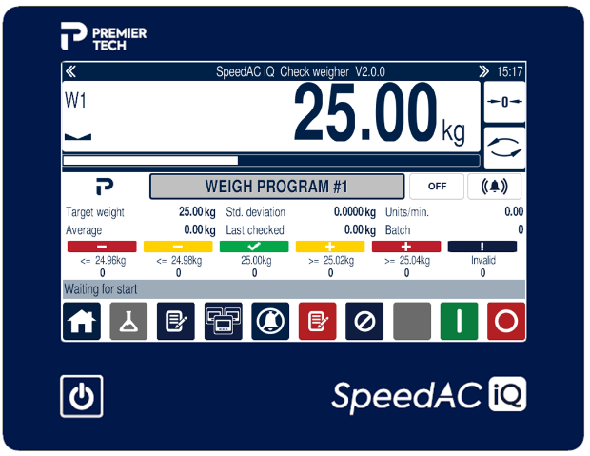  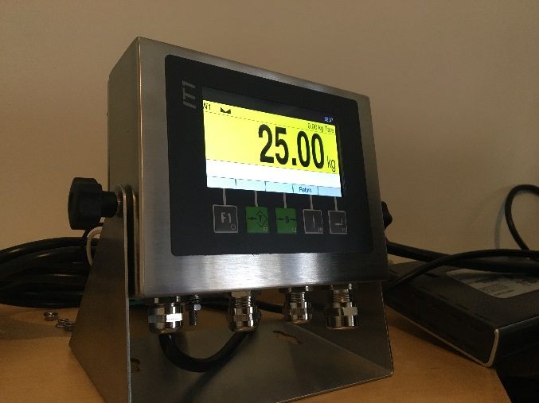

1. **Verify electrical connection between SpeedAC iQ and IT Remote display**
   1. *Verify that RS485 module is inserted in SIM2 socket of SpeedAC iQ*
   2. *Verify that RS485 module is inserted in SIM(1) socket of IT1*
   3. *Verify that connection of wires between both SIM modules correspond to electrical drawings. In case of doubt, refer to Systec manual IT1_FAZ_IAE.pdf – Section 3.4.1*
2. **Verify SpeedAC iQ Configuration**
   1. *Service Mode Entry*
      1. Application must be loaded before doing these steps
      2. Make sure you are login as *Supervisor* or *Premier Tech*
      3. Enter In service mode by touching the Weight display in Auto Screen for at least 2 seconds
      4. Service mode password is “2234”
   2. *Service mode: Continuous Output settings*
      1. Select “General” menu with  and then 
      2. Hit  until you get to “Cont.out” item
      3. Select “Sys.Remote” with  then 
      4. Select “SIM2” with  then 
      5. Type in 10 for “Cont.out Rate” for udapte per second then 
      6. “Cont.out2” must be set to *Off* with  then 
      7. Press  until you see “Service: General”
   3. *Service mode: SIM2 port settings*
      1. Select “Interface” menu with  and then 
      2. Select “Com2(SIM2)” with  then Hit 
      3. “Baud” must be set to *9600* with  then 
      4. “Databits” must be set to *8* with  then 
      5. “Parity” must be set to *None* with  then 
      6. “Ctrl.” Must be set to *None* with  then 
      7. “Protcl.” Must be set to *None* with  then 
      8. At this point you see “Interface Com2(SIM2)” press  until the iQ leave the Service Mode and go back to the Auto screen and Restart controller
   4. *Application: Machine Config. - COM2 setting*
      1. Press the Oher Pages button
      2. Then access the Machine Config. Screen 
      3. Select “Cont. out” in Com2 port



* + 1. Get Back to Auto screen 

1. **Verify IT1-remote display configuration** 
   1. *Entering Service mode*
      1. F1 to F5 keys are used to navigated in the menus



* + 1. Hit Return-F4 key to get to upper level menu (Zurück in German)



* + 1. Hit Service-F1 key to reach the *Service* mode

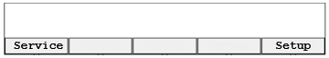

* + 1. Enter “2234” as the *Password* using F2-F2-F3-F4 keys, then Enter-F5 key

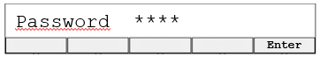

* + 1. Make sure to pick the *Service* with Select-F1 key then hit Continue-F5 key



* 1. *Configure Scale display*
     1. Use the Select-F1 key to reach the *Config.* Menu then hit OK-F5 key

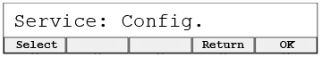

* + 1. Use the Select-F1 key to reach *Scale* Menu then hit OK-F5 key



* + 1. Use the Select-F1 key to pick *Sys.Remote* then hit OK-F5 key

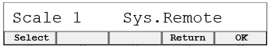

* + 1. Use the Select-F1 key to pick *SIM1* then hit OK-F5 key

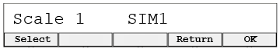

* + 1. Use the Select-F1 key to pick Scale2 *None* then hit OK-F5 key



* 1. *Configure Communication channel*
     1. Use the Return-F4 key, then use the Select-F1 key to pick *Service:* *Interface* then hit OK-F5 key



* + 1. Use the Select-F1 key to pick *Interface Com1(SIM1)* then hit OK-F5 key



* + 1. Use the Select-F1 key and OK-F5 key to set the following parameters:
       1. Baud: 9600
       2. Databits: 8
       3. Parity: None
       4. Ctrl.: None
       5. Protcl.: None
  1. *Configure Language & Time Zone*
     1. When back to Interface Com1(SIM1) menu Hit Return-F4 to reach Service main menu, then use the Select-F1 key to pick General then OK-F5 key



* + 1. Use the Select-F1 key to pick Language *English* then hit OK-F5 key



* + 1. Hit OK-F5 until *Time zone* then use the Select-F1 and Ok-F5 keys to select the exact time zone (some are inside an area i.e. Asia – Jakarta)

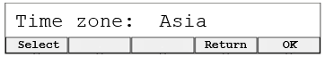

* + 1. Hit OK-F5 until back to Service menu



* + 1. Hit Return-F5 two times to get back to Application main menu
  1. *Set the Time & Date*
     1. Hit Return-F4 key then Setup-F5 key to access application setup



* + 1. Hit Continue-F5 key to set Input parameters



* + 1. Use Clear-F1, then +1-F2 to enter the most left digit first, then use the x10-F3 to create a number to the left and increment it again with +1-F2. For example, to enter 25 do the following: Clear, +1(2), x10, +1(5)



* + 1. Use the Continue-F5 key to go thru Day/Month/Year/Hour/Minute using the Clear/+1/x10 keys to adjust the Time & date fields
    2. Adjust the Brightness as desired with -10%-F2 and +10%-F3 keys then hit Continue-F5 key



* + 1. Hit Return-F4 to go back to Application main menu